Mobile Clinical Scale Collection System for In-hospital Stroke Patient Assessments Using Html5 Technology

Furu Xiang1,3, Wenxuan Guan1,3, Xingxian Huang2, Xiaomao Fan1, Yunpeng Cai1 and Haibo Yu2

1Shenzhen Institutes of Advance Technology, Chinese Academy of Sciences, Shenzhen, P.R. China

2 Shenzhen Traditional Chinese Medicine (TCM) hospital

3 University of Science and Technology of China, Hefei, P.R. China

[yp.cai@siat.ac.cn](mailto:yp.cai@siat.ac.cn)

**Abstract.** Clinical scale is a very important means of measuring and recording patient status, especially for capturing features that are not directly reflected by biochemical tests. In this paper, we develop a clinical scale collection system which enables doctors to record patient information during hospital rounds in real-time via different mobile platforms such as Android, iOS or others. The system adopts web technology that is base on the standard of Hypertext Markup Language 5.0 (HTML5) on the client, which solves the issue of platform compatibility of between systems. The technology of web service that uses the style of Representational State Transfer (REST) not only optimizes the logical structure of the system but also increase the system's scalability, and the stable MySQL database increases the security and stability of the system’s data storage. The system has been adopted in a traditional Chinese medicine hospital for in-hospital monitoring and assortment of stroke rehabilitation patients and played quite a helpful role in patient management and clinical assertions.

**Keywords:** mobile healthcare, medical scale, in-hospital patient management, health information systems

1. Introduction

Clinical assessment scales have long been developed in clinical science. In the beginning, a number of medical assessment scales were proposed in the form of index scores. For example, in clinical scales detecting risks of stroke onset, Johnston and his partner made a cohort study on 1707 patients identified with TIA (transient ischemic attack) during the 90 days, which defines the short-term prognosis and risk elements for stroke after TIA, by which they proposed a simple index, the California scores, (vary from 0 to 5 for each risk factor) to help estimate risk [1]. After that, the content of the medical assessment scales have been changed for accurately estimate patient conditions in clinical. As such, through a scoring system with clinical and Magnetic Resonance imaging (MRI) information, risk of a subsequent stroke following an acute TIA (transient ischemic attack) or minor stroke can be predicted accurately [2]. And at present, there have been many studies to verify their value to predictive patients’ disease progression. As is shown in Johnston`s research, the California and ABCD scores can predict the stroke risks at 2 days, 7 days, and 90 days (in each of the four validation cohorts). And compared with the two scores, ABCD(2) score is likely to be most predictive [3].

Meanwhile, the value of medical assessment scales has been gradually accepted by academics and clinicians. For example, in the diagnosis of TIA, Edwards` Qualitative study using semi-structured interviews shows that in two hospital sites in England, 60% Primary care staff (nine GPs and one A&E triage nurse) and 100% Specialist doctors, nurses and administrator do use the ABCD2 risk stratification score as a diagnostic tool and referral pathway facilitator, to help emphasizing urgency to the patient; Meanwhile, analysis of the ABCD2 scores was the core way to communicate about TIA diagnosis in the two sites [4].The effect of clinical scale is reflected in many aspects: to predict disease onset and find the risk factors of diseases, impact on processes of care and clinical outcomes to improve the clinical progress; assessing the development of patients` disease and the effect of rehabilitation to select the clinical therapy. Compared with other form of medical records, clinical scale systems are more powerful in incorporating expert knowledge and judgments as well as providing comprehensive assessments of patient status in systematic rather than isolated way. Hence they are indispensable in real-world clinical applications.

Currently, in most hospitals the patients’ clinical scale have to be filled in paper form by health care staff during the course of rounds, before typing into computer database afterwards, which is not only time consuming, but also overwhelming clinicians and having the risk of losing important clinical information due to overloads of working intension. Developing a mobile-based information system which can collect medical scales conveniently on real-time will dramatically help clinicians to better manage and evaluate the situation of patients, and to provide more chances of optimizing the therapy strategies in time.

In order to help health care staff to make accurate judgment of patient`s condition and improve the working efficiency of them, we develop a clinical scale collection system with the help of the hospital of Traditional Chinese Medicine of Shenzhen. The clinical scale collection system is composed of two parts: the design and development of scales’ web interface and the data Storage and processing of evaluation results. We use the HTML5 technology for the web development in order to compatible with different platforms and use Representational State Transfer (REST), which could reduce the complexity of the development and improve the scalability of the system, to implement the data submitted; and MySQL, a relational database, has been used in clinical scale collection system as its database and in the following we will introduce these technology.

1. System Architecture

Online clinical scale collection system is structured into three parts: the first part is web client which is based on the HTML5 standard. The web client based on HTML5 standard could adapt with different mobile platforms so that health care staff could use their work mobile phone, iPad and computer to evaluate patient condition, view and update evaluation results, and manage history evaluation records. Meanwhile the web client based on HTML5 standard could facilitate modular design of clinical scale so that health care staff could perfect the existing clinical scale in the process of evaluation. The second part is Middle-ware layer, we using web service and REST design style to pack/unpack evaluation data, improve data security and platform compatibility, optimize the system logical structure and facilitate the system development. The third part is database, MySQL be used as the system database to store patient condition assessment information and patient personal information, MySQL is a so mature and stable commercial database that could ensure data security. Fig.1 depicts the system 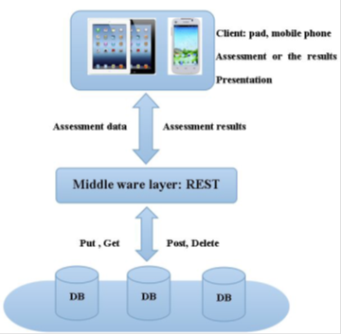structure of online clinical scale collection System.

**Fig. 1.** Architecture of the online clinical scale collection system proposed in this paper. In the client, health care staff could submit, update, delete assessment results, and view the history list of assessment results, middle ware’s main function are the assessment data encapsulation and unpacking and standardize health care staff operations.

1. Main Technologies

In this section, we mainly introduce three techniques that are used in the system development, namely, the web client development based on the HTML5 standard, and use web service and REST as middle-ware layer, and use report to represent assessment results. In the following, we will introduce their advantages and how to use them in the system.

* 1. The HTML5 standard

The HTML5 standard has become one of the hot topics of the Internet and the mainstream browsers all support it. Its advantage is reflected in two aspects, the one is the user of it, it improves user’s experience, enhanced visual experience. The standard of HTML5 enables the mobile terminal application to return to the web page, and the functionality can be extended so that the user’s operation could be easier. The other one is the developers of application, the standard of HTML5 cross-platform and multi-terminal adapter. Native App of conventional mobile terminal must be developed for different operating systems, while the development of application based on HTML5/JavaScript/CSS don’t need to consider the compatibility of the system, it can be distributed into all browsers after the development of the application is completed.

Even take the channels of traditional App Store, we can package underlying applications which is developed on the standard of HTML5 to the App, so that the costs of development is lower.

The web client development of online clinical scale collection system is based on the HTML5 standard because of its powerful features can make the system work so nice in cross-platform and multi-terminal that health care staff can smoothly evaluate and view patient’s condition on computer and mobile devices such as iPad and mobile phone.

Meanwhile, we don’ t need to consider the web client ’s compatibility, In other words, we do not have to develop client for different platforms so it can reduces unnecessary duplication work during the development of the web client of the system.

* 1. Web Service and REST

The W3C defines a web service as: a software system designed to support interoperable machine-to-machine interaction over a network. It has an interface described in a machine-processable format (specifically Web Service Description Language, WSDL). Other systems interact with the Web service in a manner prescribed by its description using Simple Object Access Protocol (SOAP) messages, typically conveyed using HTTP with an XML serialization in conjunction with other Web-related standards [5]. REST is an architectural style consisting of a coordinated set of architectural constraints applied to components, connectors, and data elements, within a distributed hypermedia system. REST ignores the details of component implementation and protocol syntax in order to focus on the roles of components, the constraints upon their interaction with other components, and their interpretation of significant data elements. In our system, there are four types of action while submitting the results of medical assessment scales [6]:

* “GET”: when you want to view clinical scales evaluation history information, the "get" will be triggered to get the information from database.
* “POST”: when you want to submit the evaluation results of clinical scale, “post” will be triggered to insert evaluation results into database.
* ”PUT”: when you want to modify the clinical scale history evaluation information which have been stored into database, "put" wil be triggered to get the information from database and then update the modified information to the database
* “DELETE”: if you want to delete useless history evaluation information, “delete” will help you to complete it.
  1. The use of Report

To display data from database for medical analysis and research, charts and cross tables are applied into the online clinical scale collection system. NVD3 is a project that builds re-usable charts and chart components for d3.js (a JavaScript library for manipulating documents based on data). Based on d3.js, NVD3 supports datasets, suitable for dealing with a large quantity of patients’ data in hospital. Meanwhile, the feature of dynamic behavior for interaction helps the health care staff analyze and investigate patients’ condition in the form of chart directly.

1. Functional Design of the System

Before designing of the online clinical scale collection system, we have done a lot of investigations to meet the requirements of health care staffs to the maximum extent. The design goal of the system is simple, stability, practical and scalable, so we did not add complex functionality. The main functions of the online clinical scale collection system are:

Scale assessment results timely presentation; data (including the results of the assessment) synchronization, storage and management; key information extraction and presentation. The following describes the main functions of the system:

* 1. Assessment Results Timely Presentation

Some results of the assessment of complex clinical scales need health care staff to calculate it with the assessment information in accordance with certain rules after the assessment complete. After investigation, we found that these calculations are lightweight computing. So during the design of the system, we put the lightweight calculations on the web client, namely , when the web client detected health care staff fill in the clinical scale, web client will calculate the results of the assessment automatically based on the information that the doctor do. Therefore, health care staff not only don’t need spend extra time to get the assessment results, but also they could view the assessment results in real time after filling out the clinical scale. So the system will improve the efficiency of the health care staff and allow health care staff to provide medical advices for the patient's condition in time.

* 1. Data Synchronization, Storage and Management

Health care staff can assess the patient's condition in the online clinical scale collection system on their Pad and other mobile devices and upload them to the database in real time to synchronize the critical information with the hospital's case library. Meanwhile, patient's disease information and assessment information can be retrieved from the hospital library and then be viewed in the form of assessment scales and line chart to obtain the changes of patient's condition; The system database stores the patients personal information, clinical scale assessment information. Each record has a registration number to mark it and registration number is the unique ID for each patient, health care staff could get all the results of the assessment of patients by it so that they could more comprehensive understanding of the patient's condition and provide more accurate follow-up treatment.

We use php-admin, a MySQL management tool which has been widely used, to manage the database rather than independently develop back-end management tool, php-admin is so independent of the database that would not increase the load on the system and reduce development costs. Meanwhile, it could manage the database nicely and easily.

* 1. Key Information Extraction and Presentation

In this system, we provide several retrieval interfaces, where the health care staff can extract the useful information from the database through some key words that provide by the retrieval interfaces. The key words could be divided into two categories, The first category which are presented in each scale and common information is stored in these key words, the others are stored the key information of each scale during the assessment. Through the two kinds of key words doctor can retrieve useful information what they need to understand the condition of patients; In the representation of information, we use report technique which is mentioned in the previous article, the system will show the information in the cross table, graphs or the other forms to present it to the health care staff so that the health care can makes a more intuitive understanding of the patient's condition changes, and in order to facilitate the collection of the clinical data, the information can be exported in the form of excel, based on this information, specialist doctors can make better treatment for the patient, meanwhile, in patients informed, specialist doctors can use the information for clinical research.

1. Applications

The system has been applied in Shenzhen Traditional Chinese Medicine (TCM) hospital, which is one of the best hospitals to treat stroke patients in Shenzhen, which have more than 1000 person-times of stroke patients hospitalized per year. At present, our system has been used for clinicians in Shenzhen TCM hospital to evaluate patients’ pathogenic condition with clinical assessment scales. The system in operation comprises altogether 29 types of medical scales in total. The application trail has been carried for one year and during this period 4890 medical scales have been collected from304 in-hospital patients.

Fig.2 show the basic statistics page of the system which can illustrate the number of medical scales collected with respect to patient, doctor or timeline. This page helps hospital managers to keep track of the workload of the doctors and the situation update of patients.

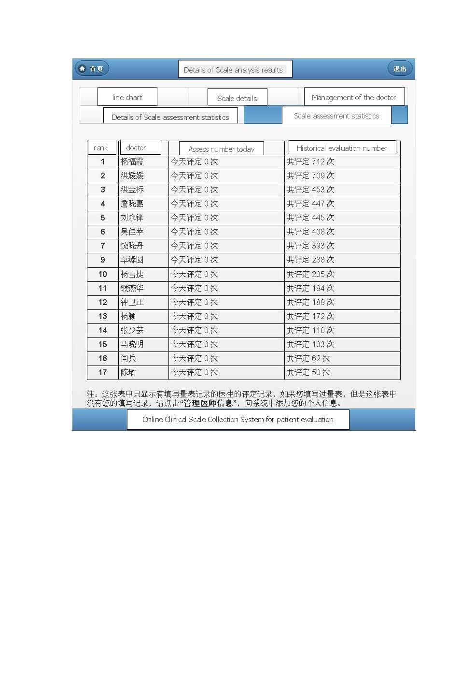

**Fig. 2.** Basic statistics page of the system displayed on a mobile device. The original interface is in Chinese and the key notations are translated into English. This page helps hospital managers to keep track of the workload of the doctors and the situation update of patients.

The system also provide survey charts to assert the overall situation of patients enrolled in the studies, including the gender, ages, type of stroke, Body Mass Index, underlying diseases, habits and customs and so on. From the pie charts, we can know more about the characteristics of stroke patients and find out the risk factors of stroke. Fig.3 shows the distribution of ages in enrolled stroke patients, Fig.4 shows the distribution of the stroke subtypes of these patients, and Fig.5 shows the distribution of recurrent history in these patients.

An important role of the online medical scale system is to help clinician to study the status change of in-hospital patients and evaluate the quality of treatment timely during hospital rounds. By accessing he assessment result histograms generated in the system from mobile devices, we can know about the curative effect before and after special treatment with clinical scales and make timely decisions. For example, Fig.6 compares the curative effect of a group of patients before and after receiving acupuncture treatments. The average score on multiple patients are displayed. We see that the National Institute of Health Stroke Scale (NIHSS) score of patient drop sharply after therapy, indicating an efficient outcome of the acupunctures. On the other hand, Fig.7 displays the Barthel Index Assessment of a studied stroke patient in different assessment stage, which is another important metric for measuring the rehabilitation status of stroke patients.

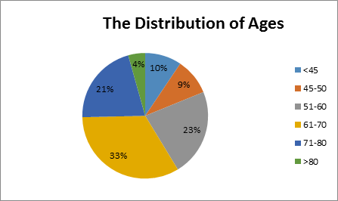**Fig. 3.** The distribution of ages in stroke patients enrolled in the system

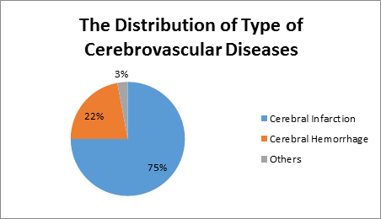**Fig. 4.** The distribution of stroke type for patients enrolled in the system.

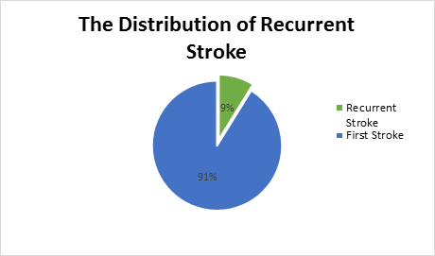**Fig. 5.** The distribution of recurrent stroke in enrolled stroke patients.

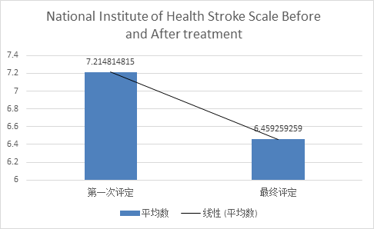**Fig. 6.** The curative effect before and after acupuncture treatment with National Institute of Health Stroke Scale (NIHSS). The Chinese contents exist in the original interface is replaced by English notations.

After Theraphy

Before Theraphy

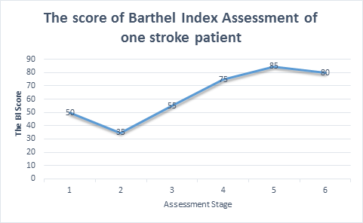**Fig. 7.** The score of Barthel Index Assessment of a stroke patient in different assessment stage.

1. CONCLUSION

Online clinical scale collection system is effective for clinicians to evaluate the state of patients’ condition. Clinicians could assess the patients’ quality of life, psychology, the risk of second attack of stroke with the system. Besides, it is not only convenient for clinicians to take clinical data from patients at their bedside with mobile phones or iPad portable computers, understand the patients comprehensively, guide clinical diagnosis and treatment, but also transform the data to the simplified, visualized statistical charts to assist hospital managements and clinical decision optimizations. In the future, the system would link with hospital information system seamlessly and become an important part of the hospital information system.

1. Acknowlegements

This work was supported by Shenzhen Municipal Science and Technology Research Development and Funds and Platform Construction Plan Key Laboratory Program (CXB201111250113A), Shenzhen Basic Research Fund (JCYJ2013-0329155553732), the Promotion Funds for Key Laboratory in Shenzhen (ZDSY-20120617113021359) and Shenzhen Innovation Funding for Advanced Talents (KQCX20130628112914291).

1. REFERENCES
2. JOHNSTON S C,GRESS D R,BROWNER W S, et al. Short-term prognosis after emergency department diagnosis of TIA[J].JAMA,2000,284(22):2901-2906.).
3. COUTTS S B, ELIASZIW M, HILL M D, et al. An improved scoring system for identifying patients at high early risk of stroke and functional impairment after an acute transient ischemic attack or minor stroke[J]. International journal of stroke, 2008,3(1):3-10.
4. Johnston SC. Rothwell PM. Nguyen-Huynh MN, et al. Validation and refinement of scores to predict very early stroke risk after transient ischemic attack[J]. 2007(9558).
5. EDWARDS D,COHN S R,MAVADDAT N, et al. Varying uses of the ABCD2 scoring system in primary and secondary care: a qualitative study[J]. BMJ open, 2012, 2(6):1-6.
6. “Web Services Glossary” W3C. February 11, 2004. Retrieved 2011-04-22.
7. Fielding Roy T., Taylor Richard N. "Principled Design of the Modern Web Architecture"May 2002